**Maintenance Cost Analysis - Manufacturing Sector**

GOKULNATH K & E24755

**Overview**

Maintenance Cost Analysis in the manufacturing sector involves assessing costs related to equipment upkeep, repairs, and downtime, aiming to reduce operational expenses. Data analysts gather and analyze maintenance data, identify cost patterns and key metrics like Mean Time Between Failures (MTBF), and use predictive modeling to forecast maintenance needs. This enables proactive decision-making, improving resource allocation and maintenance scheduling. Ultimately, the analysis helps minimize costs, enhance equipment reliability, and increase production efficiency.

**Objective**

1. **Cost Reduction:** Identify and reduce unnecessary maintenance expenses.
2. **Efficiency Improvement:** Optimize maintenance schedules to minimize equipment downtime.
3. **Reliability Enhancement:** Increase asset reliability by analyzing failure patterns and key metrics.
4. **Predictive Maintenance:** Use data to forecast and prevent potential failures.
5. **Resource Allocation:** Improve resource planning for labor, parts, and materials based on data insights.

**Assigned Task(s)**

* Maintenance Cost Analysis - Manufacturing Sector.
* **Status:** Completed.
* **Details:**

1. Total Maintenance Cost by Equipment Type: Summed maintenance costs per equipment type; bar plot highlights high-cost equipment.
2. Total Downtime by Equipment Type: Aggregated downtime hours for each equipment type to identify top contributors to operational impact.
3. Monthly Maintenance Cost Trend: Tracked monthly maintenance costs to reveal seasonal patterns or cost spikes.
4. Labor Hours by Equipment Type: Box plot shows labor hour variability across equipment types.
5. MTBF vs. MTTR Analysis: Scatter plot of equipment reliability (MTBF vs. MTTR) to pinpoint critical equipment with frequent/long repairs.
6. Repair Frequency by Equipment Type: Bar plot of repair frequency per equipment type to support preventive maintenance.

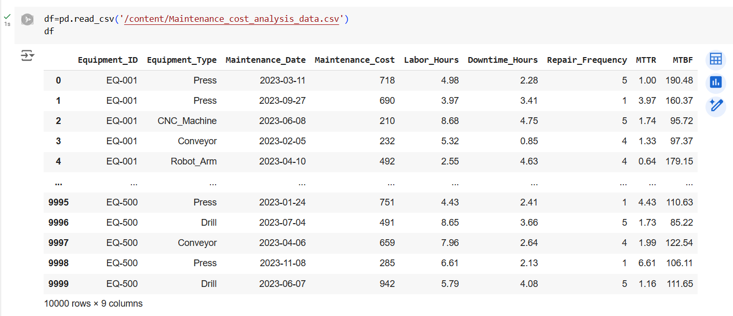

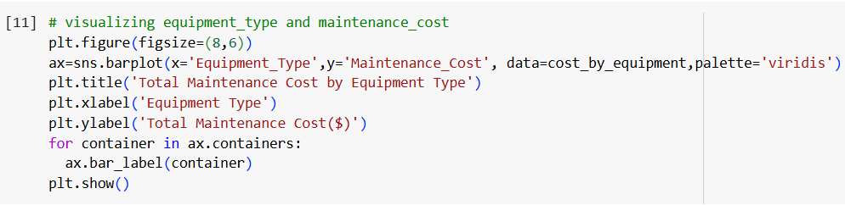

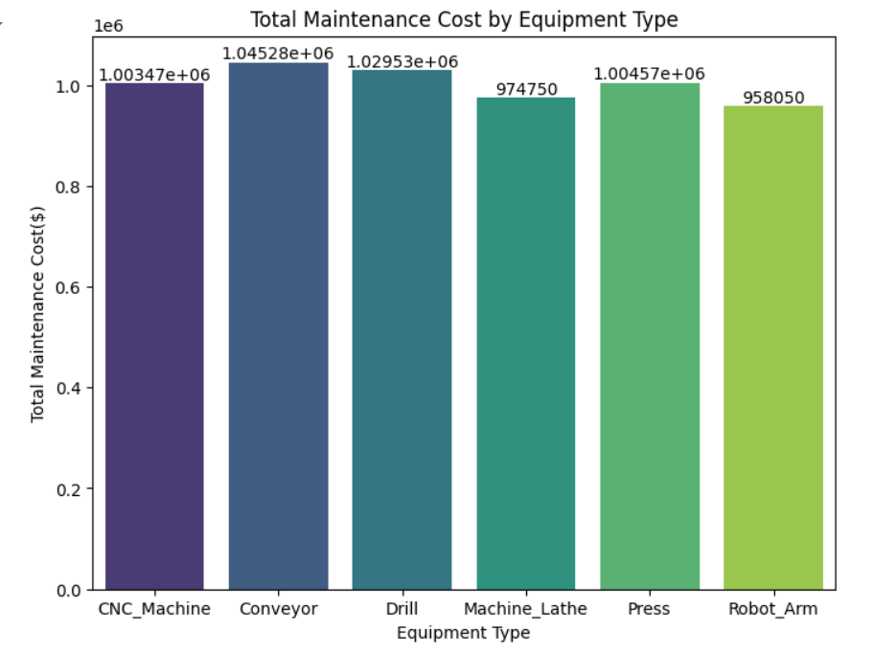

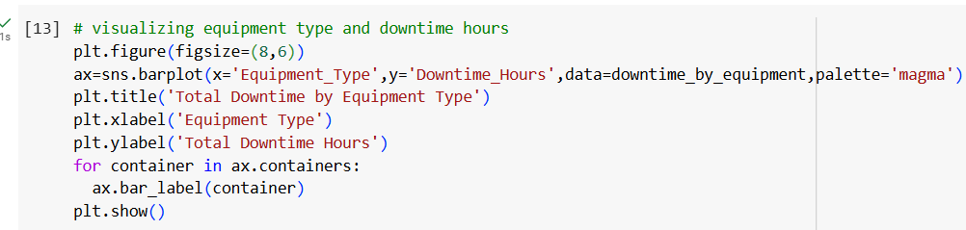

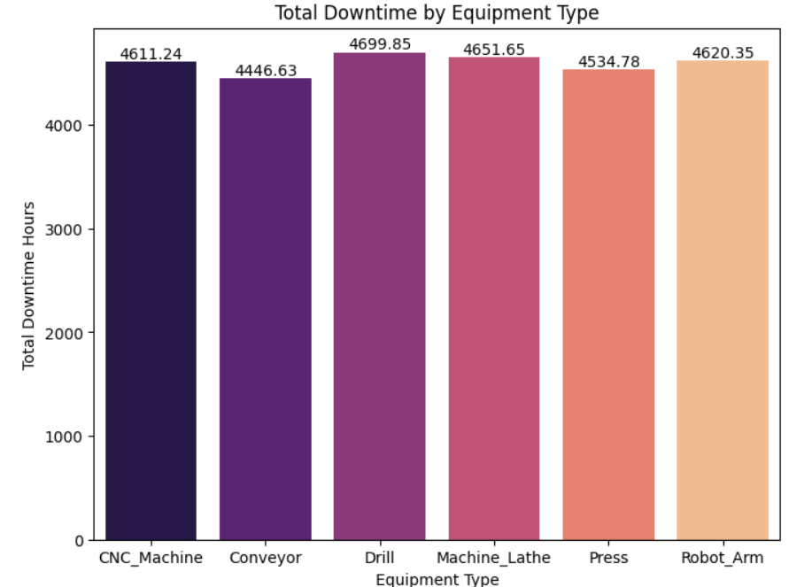

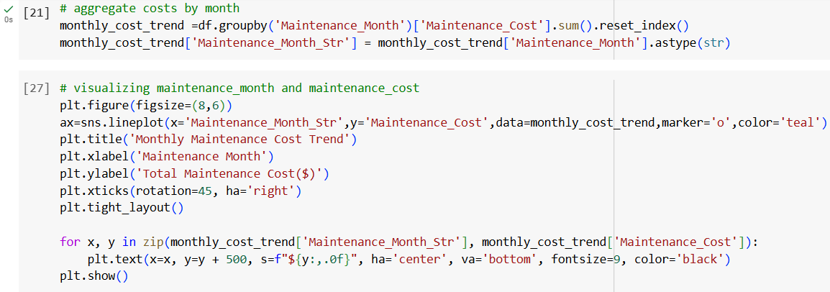

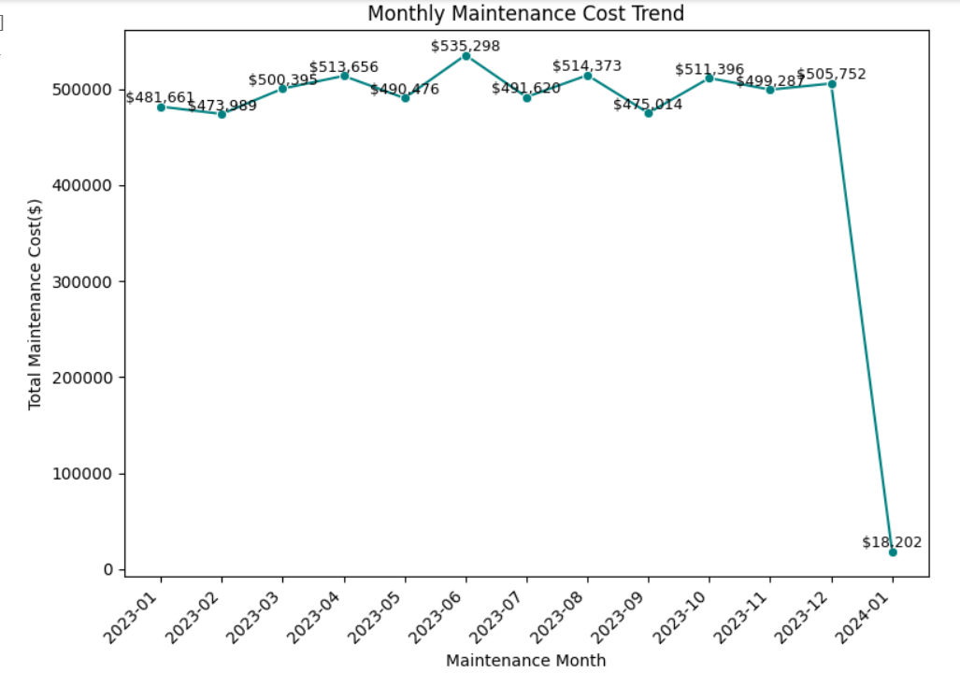

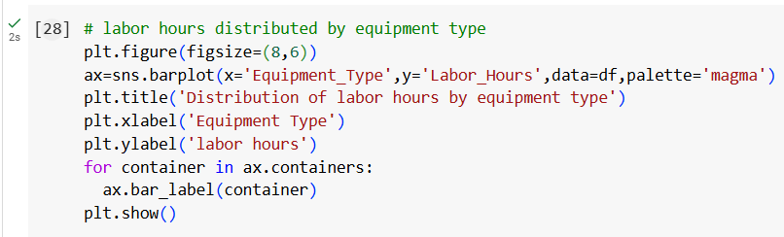

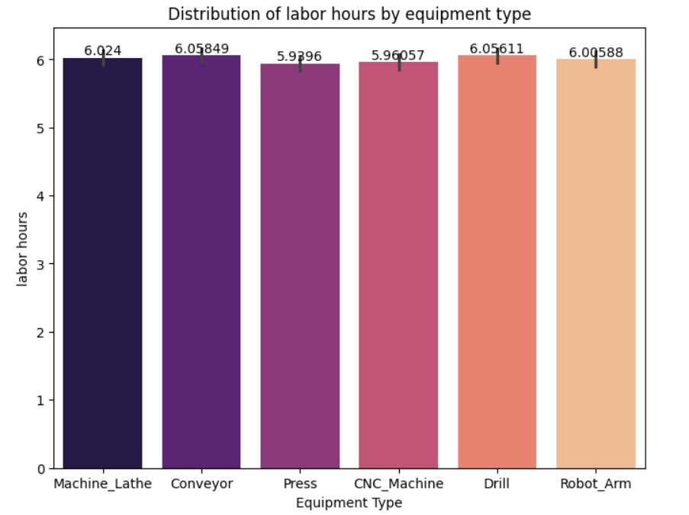

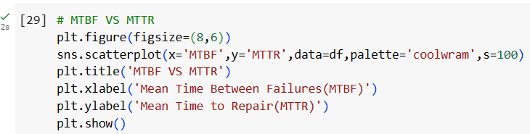

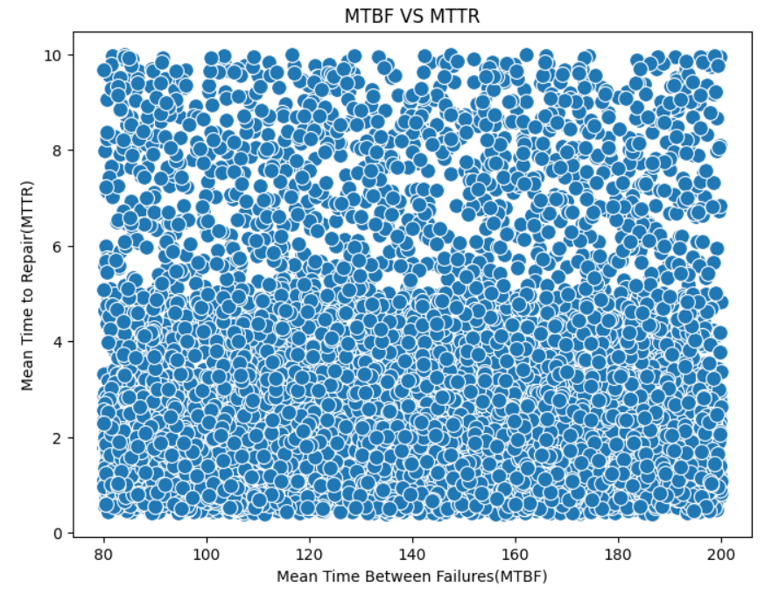

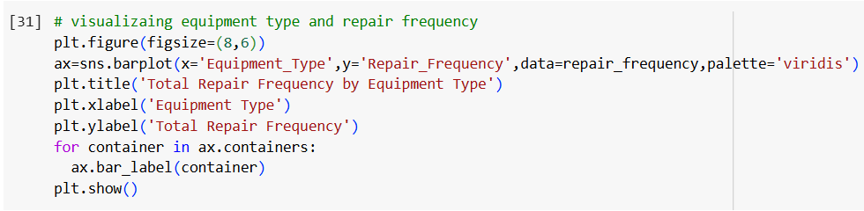

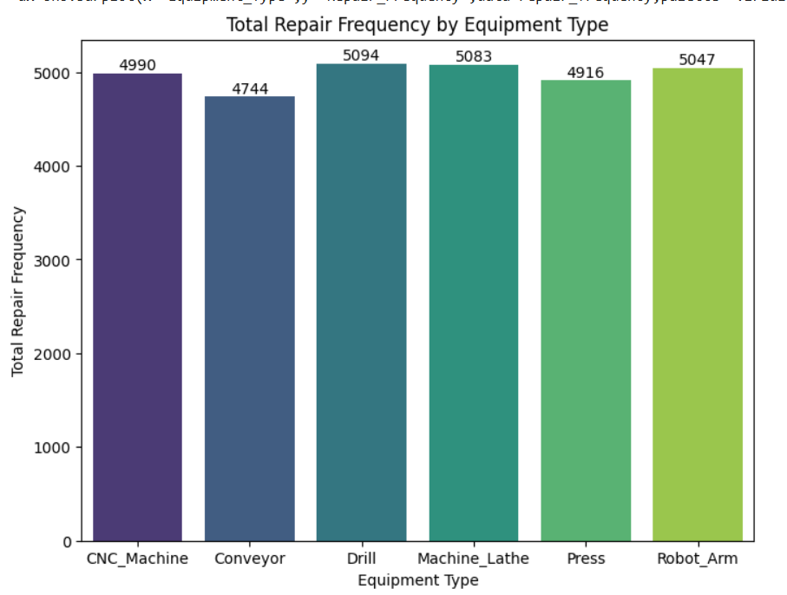

**Progress**

* **Accomplishments:**

1. Identified High-Cost Equipment: Pinpointed equipment types with the highest maintenance costs, supporting budget prioritization.
2. Highlighted Major Downtime Contributors: Isolated equipment with significant downtime, aiding in targeted maintenance.
3. Revealed Cost Trends: Tracked monthly cost trends, helping detect seasonal cost drivers and unexpected spikes.
4. Analyzed Labor Variability: Assessed labor hours across equipment types to optimize resource allocation.
5. Enhanced Reliability Insights: Compared MTBF vs. MTTR to prioritize maintenance on frequently failing, high-impact equipment.
6. Supported Preventive Maintenance: Visualized repair frequency, guiding proactive maintenance strategies for critical equipment.

* **Metrics:**

1. Measures cumulative costs by equipment type, identifying cost-intensive assets.
2. Tracks total downtime for each equipment type to gauge operational impact.
3. Monitors month-over-month maintenance expenses, revealing seasonal trends or anomalies.
4. Captures labor time allocation, highlighting equipment with higher labor requirements.
5. Mean Time Between Failures (MTBF): Evaluates equipment reliability by measuring time between breakdowns.
6. Mean Time to Repair (MTTR): Measures average repair time, indicating equipment with prolonged recovery times.
7. Counts repair instances for each equipment type, supporting preventive maintenance prioritization.

**Challenges and Solutions**

* **Challenges Faced:**

1. Inconsistent or incorrect data can lead to unreliable analysis.
2. Employees may resist new maintenance strategies or technologies.

* **Solutions Implemented:**

1. Implement robust data validation and cleaning processes to ensure accuracy.
2. Conduct training sessions and demonstrate the benefits of new approaches to gain buy-in.

**Next Steps**

* **Upcoming Tasks:** Identify and tackle tasks that have the greatest impact and urgency first.
* **Goals:** Outline clear and quantifiable goals for each task to track progress effectively.

**Conclusion**

* **Summary:** Maintenance Cost Analysis in the manufacturing sector is essential for optimizing resources, enhancing equipment reliability, and reducing operational costs. By leveraging data-driven insights, establishing clear metrics, and addressing common challenges, organizations can develop proactive maintenance strategies that align with business goals. This comprehensive approach ultimately leads to improved productivity, reduced downtime, and increased profitability.
* **Acknowledgements:** Thank you all for your attention and engagement, I appreciate your interest in the Maintenance Cost Analysis - Manufacturing Sector.